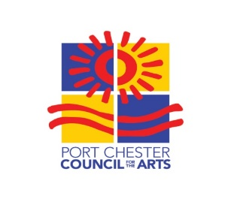

INSTRUCTIONS FOR ARTISTS FOR ART10573

ART10573 supports and highlights the work of professional local artists in- and outside of our community.

ART10573 will take place indoors at:
Crawford Mansion Community Center
122 N. Ridge St., Rye Brook, New York 10573
Sunday, October 24, 2021
11am to 5pm

Timing:
- Set-up begins at 10 a.m. and you will be assigned an exhibit space. (Show opens at 11 a.m.)
Set-Up:
- Plan to exhibit 10 to 12 pieces (additional portfolio pieces welcome).
- Your allotted space is 8-feet long.
- Bring your own display such as easels and/or racks; tables and folding chairs will be provided (mark application if you need a 6-foot rectangular table for display purposes).
- All work must remain on display until 5 PM (no early departures, please).
Other details:
- Entry fee is $50. Artists requested to donate a small piece of work for a raffle to benefit the scholarship fund of PCCFA Summer ArtsCamp.
- No commission taken on pieces sold.
- Lunch, bottled water and coffee will be provided for artists.
- Kindly RSVP by Friday, October 1, 2021.
- Your acceptance as an exhibiting artist will be confirmed by e-mail or phone within 2 weeks of receipt of your application.
- Town of Rye Covid-19 protocols will be followed.

Please complete the Application form and include:
- An updated bio (for publicity purposes) with a brief description of your work.
- $50 entry fee made payable to Port Chester Council for the Arts and mail to:
P.O. Box 15, Port Chester, NY 10573-0015, no later than Friday, October 1, 2021.
- Email 3 publicity ready images of your current work that represents medium for exhibit at ART10573 to: anna.m.kamensky@gmail.com.

For additional information or questions contact ART10573 co-chairs:

Anne Brady: 914-934-1015; avbrady33@verizon.net
Sue Covino: 914-939-6690; spcovino@verizon.net
Anna Kamensky: 914-886-2601; anna.m.kamensky@gmail.com

PCCFA, P.O. Box 15, Port Chester, NY 10573-0015 914.224.4813 www.portchestercfa.org

