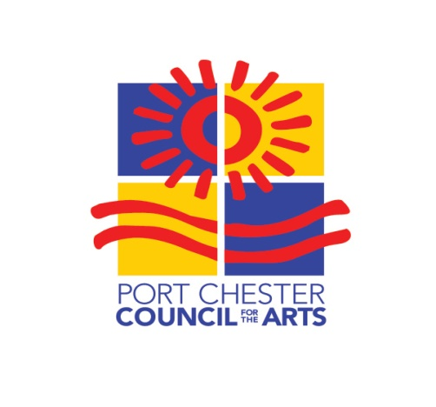
ART10573
October 24, 2021
Artist Application 2021

Artist’s Name:

Artist’s Medium:

Artist’s mailing address:

Contact number:

Email:

SIGNATURE: Date:

I have enclosed $50 Entry fee __
I have attached a bio for publicity __
I have emailed 3 images of the medium I plan to exhibit to anna.m.kamensky@gmail.com __
I will need a folding table for display __ Number of folding chairs needed __

Mail completed application along with a $50 check made payable to Port Chester Council for the Arts, Inc., P.O. Box 15, Port Chester, NY 10573-0015 by Friday, October 1, 2021.

Inquiries:
Anne Brady: 914-934-1015; avbrady33@verizon.net
Sue Covino: 914-939-6690; spcovino@verizon.net
Anna Kamensky: 914-886-2601; anna.m.kamensky@gmail.com

PCCFA, P.O. Box 15, Port Chester, NY 10573-0015 914.224.4813 www.portchestercfa.org

